**DATA SCIENCE PROJECT ON FIFA20**

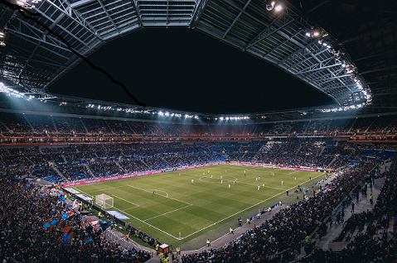

**PROJECT ID : PRCP-1004-Fifa20**

**BUISNESS CASE:**

**WITH THE FIFA20 DATASET WE NEED TO CLUSTER THE PLAYER BY THEIR SKILL INTO CERTAIN GROUP**

**TASK : CLUSTeRINg**

INTRODUCTION OF PROJECT:

FIFA 20 is a football simulation video game published by Electronic Arts as part of the FIFA series. It is the 27th installment in the FIFA series, and was released on 27 September 2019 for Microsoft Windows, PlayStation 4, Xbox One, and Nintendo Switch.

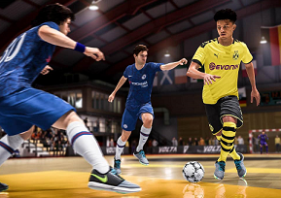

**SOFIFA-ID:**

Id of fifa20 player

**PLAYER URL:**

A URL (Uniform Resource Locator) is a unique identifier used to locate a resource on the Internet. It is also referred to as a web address.

**SHORT NAME:**

Short or nick name, Name of player

**LONG NAME:**

Full name of player

**AGE:**

Age in years

**DOB:**

Date of birth of player

**HEIGHT CM:**

Player height in centimeter

**WEIGHT KG:**

Player body weight

**NATIONALITY:**

Nationality is the legal status, which represents the country from which an individual belongs.

**CLUB:**

A group of people formed for the purpose of playing sports.

**OVERALL:**

The OVR (Overall) is made up of all the player's in game stats.

**POTENTIAL:**

The potential rating is the rating they will achieve for sure during the FIFA 20 career model.

**VALUE EUR:**

The value of player in euro.

**WAGE EUR:**

A living wage is the amount of income needed to provide an player with a basic but socially acceptable standard of living.

**PLAYER POSITIONS:**

Positions indicate approximately where each player should be lined up prior to the start of a play.

**PREFEERED FOOT:**

Footedness may refer to the foot a player uses to kick with the greatest force and skill.

**INTERNATIONAL REPUTATION:**

International reputation is rated with 1-5 stars.

**WEAK FOOT:**

A player's foot (left or right) that is weaker than their preferred foot. A player's attribute rated between 1 to 5 which specifies the shot power and ball control for the other foot of that player than his preferred foot's.

**SKILL MOVES:**

Skill moves, it is assigned a number between 1 (least complex) and 5 (most complex). Players with higher skills are able to perform more complex moves.

**WORK RATE:**

Work rates are how hard the player works on each end of the field.

**BODY-TYPE:**

A custom body type and character of football player.

**REAL FACE:**

Face scan of real football player if it 'yes' then the character is look super realistic.

**RELEASE CLAUSE EUR:**

A release clause is the minimum amount of money you're willing to accept for that player.

**PLAYER TAGS:**

The tags of player is identified the player skills, like [Dribbler, Distance shooter, Crosser, Speedster]

**TEAM POSITION:**

The player’s positioning on the field

**TEAM JERSEY NUMBER:**

The number on the back of a football player's jersey is to identify a specific player.

**LONED FROM:**

It's a temporary restriction placed on player due to their club being short of players.

**JOINED:**

Joining date of club

**CONTRACT VALID UNTIL:**

The end year of contract of players.

**NATION POSITION:**

Nation position is similar to the team position of players.

**NATION JERSEY NUMBER:**

Jersey number of player.

**PACE:**

Fastest pace of player, striker or winger

**SHOOTING:**

Shooting is hitting the ball in an attempt to score a goal. It is usually done using the feet or head.

**PASSING:**

The purpose of passing is to keep possession of the ball by maneuvering it on the ground between different players with the objective of advancing it up the playing field.

**DRIBLING:**

Dribbling Is Maneuvering A Ball By One Player While Moving In A Given Direction, Avoiding Problems’ Attempts To Intercept The Ball.

**DEFENDING:**

Defending is most relate to the defender to stop the attack

**PHYSIC:**

Physic in player means intensity and their effort.

**GK DIVING:**

Goal keeper diving to save a shot.

**GK HANDLING:**

As a goalkeeper, you are allowed to handle the ball with your hands within your penalty area.

**GK KICKING:**

The goalkeeper is the player, who usually kicks the ball to resume play, and they either kick it short to a teammate or it is kicked extremely hard to travel a long distance.

**GK REFLEX:**

Ability to react quickly.

**GK SPEED:**

Speed of goal keeper.

**GK POSITIONING:**

Position of goal keeper is around only goal posts.

**PLAYER TRAITS:**

A player’s traits are actions that he will be more likely to perform in matches.

**ATTACKING CROSSING:**

The aim of a cross is to create the easiest possible scenario for the attacking player to score a goal.

**ATTACKING FINISHING:**

Create a attack on field to score a goal

**ATTACKING HEADING ACCURACY:**

One of the fundamental principles of the attacking header is to head the ball downwards.

**ATTACKING SHORT PASSING:**

Short passes of ball to score a goal

**ATTACKING VOLLEYS:**

A volley is an air-borne strike in association football, where a player's foot meets and directs the ball in an angled direction before it has time to reach the ground.

**SKILL DRIBBLING:**

The score of dribbling skill with football

**SKILL CURVE:**

The curve of football at the time of goal

**SKILL FK ACCURACY:**

It stands for field goal. It is when a player kicks a ball through the uprights from a set distance.

**SKILL LONG PASSING:**

The long passing skill score of the player

**SKILL BALL CONTROL:**

The ball control of the player at playing time

**MOVEMENT ACCERLATION:**

how quickly player can increase your velocity towards maximum speed.

**MOVEMENT SPRINT SPPED:**

Sprinting speed score of the player.

**MOVEMENT AGILITY:**

Agility is the ability to move quickly and easily, including moving in different directions without losing balance

**MOVEMENT REACTION:**

The score of the quick relation of player.

**MOVEMENT BALANCE:**

Balance is the ability to control your body in its own space.

**SHOT POWER:**

Power generates to score a goal.

**POWER JUMPING:**

The jumping ability of the player on field.

**POWER STAMINA:**

Stamina of player on filed.

**POWER STRENGTH:**

Strength of player on field.

**POWER LONG SHOT:**

Total no of power long shot of football.

**MENTAILITY AGGRESSION:**

Aggression is a characteristic that can have many negative as well as positive effects on performance of player.

**MENTALITY INTERCEPTION:**

Interception is thrown the possession of the ball is given to the other team.

**MENTALITY POSITIONING:**

The mentality positioning of player determines how defensive or attacking your players set out to play.

**MENTALITY VISION:**

The vision/mindset of player on filed.

**MENTALITIES PENALTIES:**

When a player commits an infraction against the rules of the game a foul will be called and a penalty will be assessed.

**MENTALITY COMPOSURE:**

Composure stands for: Recognize–Regroup–Refocus. The first step is to Recognize that you are dwelling on the mistake, which limits your ability focus on the next play.

**DEFENDING MAKING:**

When your team is defending, you want to make the field small and the options of the other team limited.

**DEFENDING STANDING TACKLE:**

Defending standing Tackle of the player to get a ball on filed.

**DEFENDING SLIDING TACKLE:**

Defending sliding tackle of player to get a ball.

**GOALKEEPING DIVING:**

Goal keeper diving to save a goal.

**GOALKEEPING HANDLING:**

Handle the ball with your hands within your penalty area.

**GOALKEEPING KICKING:**

A kick taken by the goalkeeper when the attacking team has kicked the ball over the goal line.

**GOALKEEPING POSITIONING:**

A Positioning of player to save the goal.

**GOALKEEPING REFLEX:**

The reflex of goalkeeper and players.

**THE REMAINING FEATURE IS THE ABBREVATION OF FOOTBALL POSITION SCORE:**

**LS:**

Long snapper or left striker.

**ST:**

Striker

**RS:**

Right striker

**LW:**

Left sided wingers.

**LF:**

Left forward

**CF:**

Center forward

**RF:**

Right forward

**RW:**

The RW is usually on the right end of the attacking trident, with the Striker and Left Winger, which mainly contributes to the team in terms of goals and assists.

**LAM:**

Left attacking midfield

**CAM:**

Center attacking midfield

**RAM:**

Right attacking midfield

**LM:**

Left midfield

**LCM:**

Left center midfield

**CM:**

Center Midfield

**RCM:**

Right center midfield

**RM:**

Right midfield

**LWB:**

Left Wing Back

**LDM:**

Left defensive midfield

**CDM:**

Center defensive midfield

**RDM:**

Right defensive midfield

**RWB:**

Right wing back

**LB:**

Left back

**LCB:**

Left center back

**CB:**

Center back

**RCB:**

Right center back

**RB:** Right back

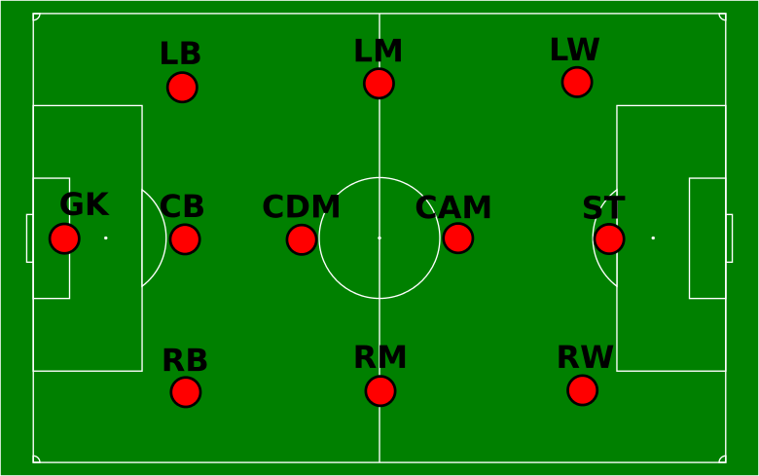

EXPLOTARY DATA ANALYSIS

UNIVARIATE ANALYSIS

OBSEVATION:

**1.AGE:**

* The range of player age between 16 to 42 with the average of 25.3

**2. HEIGHT CM:**

* The average height of pplayer is 181.4cm, maximum height is 205 and minimum height is 156cm.

**3. WEIGHT KG**:

* The range of weight of player between 50 to 110kg.

**4. OVERALL:**

* The maximum score of stats is 94 and minimum is 48.0 with the average of 66.2

**5. POTENTIAL:**

* The maximum score of player potential is 95.0 and minimum score of potential is 49.0

**6. VALUE EUR:**

* The average value of player is 2.5million.
* Maximum value of player is 105.5 million.

**7. WAGE EUR:**

* The maximum living wage of player is 565k with the average of 9k.

**8. PREFEERED FOOT:**

* 75% of player preferred right foot.
* 25% of player preferred left foot.

**9. INTERNATIONAL REPUTATION:**

* The range of international reputation is 1 to 5.
* 92% of player rated with 1, 6% of player is rated with 2 and remaining player rated with 3, 4, 5 rating.

**10. WEEK FOOT:**

* A week foot is rated between 1 to 5.
* Most of week foot player rating is 3

**11. SKILL MOVES:**

* The skill moves range between 1 to 5.
* 2 skill moves is maximum in player as well as 36% is 3 and 11% is 1 skill moves.

**12. WORK RATE:**

* The maximum 54% count of work rate is medium then 18% is high/medium.

**13. BODY TYPE:**

* 59% player body type is normal
* 36% player body type is lean.

**14. REAL FACE:**

* 89% player face is not real and remaining 11% face is real in game.

**15. RELEASE CLAUSE EUR:**

* The maximum release clasue of player is 165.8million with the average of 4.7 million

**16. PLAYER TAGS:**

* Strength, acrobat, engine, and speedster this tags is most in player tags

**17. TEAM POSITION & NATION POSITION:**

* The maximum 7280 is SUB, 2958 is RES team posistion
* remaining all position is less than 5%

**18. TEAM JERSEY NUMBER:**

* The range of team jersey number is 1 to 99.
* Maximum team jersey number between 1 to 40.

**19. CONTRACT VALID UNTIL:**

* Most of the player contract valid until 2020, 23% player contract valid until 2021
* The range of contract year between 2019 to 2026.

**20. NATION JERSEY NUMBER:**

* The range of nation jersey number between 1 to 30.
* Most of the jersey no between 1 to 20.

**21. PACE:**

* The most of the pace of player between 60 to 80.

**22. SHOOTING:**

* The range of shooting score between 15 to 93, Most number of shooting score around 25 to 70

**23. PASSING:**

* The range of passing score of the player is 24 to 92 with the average 57.2.

**24. DRIBBLING:**

* The most no of dribbling score between 50 to 80.

**25. DEFENDING:**

* The range of defending between 15 to 90.the Most no of defending score between 50 to 70.

**26. PHYSIC:**

* The physic score range between 27.0 to 90.0 the most no of physcore between 60 to 80

**27. GK DIVING:**

* Most no of score of gk diving between 60 to 70
* The range of gk diving between 44 to 90.

**28. GK HANDLING:**

* The most observation of gk handling between 60 to 70, maximum score is 92 and minimum score is 42

**29. GK KICKING:**

* The range of gk kicking in between 35.0 to 93.0 with the average of 61.8.

**30. GK REFLEX**:

* Most of the gk reflex between 60 to 70.

**31. GK SPPED:**

* The highest speed of of gk is 65.0, most no of gk speed between 25 to 50

**32. GK POSITIONING:**

* Most gk positioning score is 65 and maximum score is 91 as well as minimum score is 41

**33. ATTACKING CROSSING:**

* The attacking crossing range between 5 to 93, the most observation of attacking passing between 50 to 70

**34. ATTACKING FINISHING:**

* Most of the attacking finishing is 60,Maximum 95 and minimum 2 attacking finishing.

**35. ATTACKING HEADING ACCURACY:**

* Heading accuracy range between 5 to 93,most observation of attacking heading accuracy between 50 to 60

**36. ATTACKING SHORT PASSING:**

* most observation of attacking short passing between 60 to 70

**37. ATTACKING VOLLEYS:**

* most observation of attacking volleys between 30 to 70 with the average of 42.8.

**38. SKILL DRIBBLING:**

* most observation of skill dribbling is 65.
* The range of skill dribbling between 4 to 97

**39. SKILL CURVE:**

* The most observation of skill curve between 40 to 70, maximum score is 94 and minimum score is 6

**40. SKILL FK ACCURACY:**

* The maximum accuracy is 94 and minimum accuracy is 4 with the average of 42.7

**41. SKILL LONG PASSING:**

* The most observation of skill long passing between 50 to 60, maximum score is 92 and minimum score is 8

**42. SKILL BALL CONTROL:**

* The maximum skill ball control is 96 and minimum skill ball control is 5 with the average of 58.5

**43. MOVEMENT ACCELERATION:**

* The most observation of movement acceleration between 60 to 80, maximum score is 97 and minimum score is 12

**44. MOVEMENT SPRINT SPPED:**

* Maximum sprint speed is 96 and minimum sprint speed is 11 with the average of 64.4

**45. MOVEMENT AGILITY:**

* Maximum movement agility is 96 and minimum movement agility is 11 with the average of 63.5

**46. MOVEMENT REACTION**:

* Maximum movement reaction is 96 and minimum movement reaction is 21 with the average of 61.8

**47. MOVEMENT BALANCE:**

* The range of movement balance is 12 to 97 with 64.9 average.

**48. POWER SHOT POWER:**

* Maximum shot power is 95 and minimum shot power is 14 with the average of 58.2

**49. POWER JUMPING:**

* Maximum power jumping is 95 and minimum power jumping is 19 with the average of 64.9

**50. POWER STAMINA:**

* Maximum power stamina is 97 and minimum shot stamina is 12 with the average of 62.9

**51. POWER STRENGTH:**

* Maximum power strength is 97 and minimum power strength is 20 with the average of 65.2

**51. POWER LONG SHOT:**

* Maximum power long shot is 94 and minimum power long shot is 4 with the average of 46.8

**52. MENTALITY AGGRESSION**:

* Maximum mentality aggression is 95 and minimum mentality aggression is 9 with the average of 55.7

**53. MENTALITY INTERCEPTIONS:**

* Maximum mentality interception is 93 and minimum mentality interception is 3 with the average of 46.3

**54. MENTALITY POSITIONING:**

* Maximum mentality positioning is 95 and minimum mentality positioning is 2 with the average of 50.1

**55. MENTALITY VISION:**

* Maximum mentality vision is 94 and minimum mentality vision is 9 with the average of 53.6

**56. MENTALITY PENALTIES:**

* Maximum mentality penalties is 92 and minimum mentality penalties is 7 with the average of 48.7

**58. MENTALITY COMPOSER:**

* Maximum mentality composure is 96 and minimum mentality composure is 12 with the average of 58.5

**59. DEFENDING MARKING:**

* Maximum defending marking is 94 and minimum defending marking is 1 with the average of 46.8

**60. DEFENDING STANDING TACKLE:**

* Maximum defending standing tackle is 92 and minimum defending standing tackle is 5 with the average of 47.6

**61. DEFENDING SLIDING TACKLE:**

* Maximum defending sliding tackle is 90 and minimum defending sliding tackle is 3 with the average of 45.6

**62. GOALKEEPING DIVING:**

* Maximum goalkeeping diving is 90 and minimum goalkeeping diving is 1 with the average of 16.6

**63. GOALKEEPING HANDLING:**

* Maximum goalkeeping diving is 92 and minimum goalkeeping diving is 1 with the average of 16.4

**63. GOALKEEPING KICKING:**

* Maximum goalkeeping diving is 93 and minimum goalkeeping diving is 1 with the average of 16.2

**63. GOALKEEPING POSITIONING:**

* Maximum goalkeeping diving is 91 and minimum goalkeeping diving is 1 with the average of 16.4

**63. GOALKEEPING REFLEX:**

* Maximum goalkeeping diving is 92 and minimum goalkeeping diving is 1 with the average of 16.7

**64. PLAYER POSITIONS**

[LS, ST, RS, LW, LF, CF, LF, RW, LAM, CAM, RAM, LM, LCM, CM, RCM, RM, LWB, LDM, CDM, RDM, RWB, LB, LCB, CB, RCB, RB]

* This all position scores are almost same as well as most of the observation range between 56 to 63

**BIVARIATE AND MULTIVARIATE ANALYSIS**

**NUMERICAL VERIABLE:**

**1.IMPACT OF AGE TO MOVEMENT REACTION:**

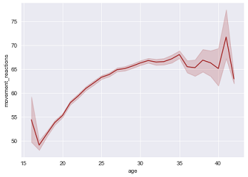

**OBSERVATION:**

* At the age 15 to 20 movement reaction is less.
* If player age is increasing player movement reaction also increasing.

**2. IMPACT OF HEIGHT TO WEIGHT:**

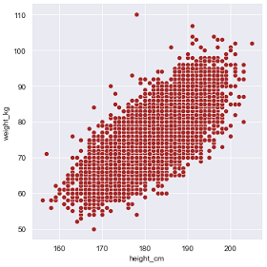

**OBSERVATION:**

* If the players height is increases player weight also increases.

**3. RELATION BETWEEN OVERALL AND POTENTIAL WITH RESPECT TO PREFERRED FOOT:**

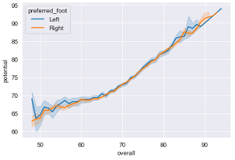

**OBSERVATION:**

* If the players overall score is increasing the score of potential also increasing with both foot.

**4. RELATION BETWEEN VALUE EUR AND WAGE EURO WITH RESPECT TO PREFERRED FOOT:**

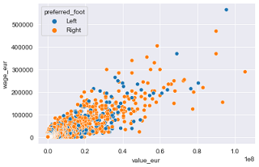

**OBSERVATION:**

* If player value is less then the wage of player also less.
* If the value of player is more the wage is slightly more.

**5. IMPACT OF CONTRACT VALID UNTIL TO RELEASE CLAUSE EUR:**

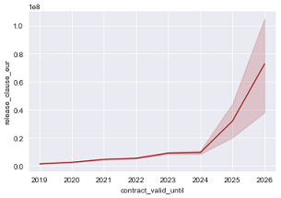

**OBSERVATION:**

* If player contract valid until 2024 to 2026 then the relase clause of player is more.
* If player contract valid until 2019 to 2024 then the release clause of player is less.

**6. RELATION BETWEEN PACE AND SHOOTING WITH RESPECT TO PREFERRED FOOT**

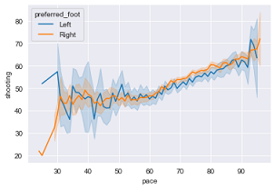

**OBSERVATION:**

* If the player preferred left foot then the pace is less but shooting is around 50 to 60.
* If the player preferred right foot then the pace is less as well as shooting also l

**7. IMPCAT OF DRIBBLING TO DEFENDING:**

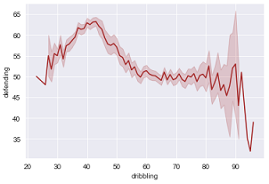

**OBSERVATION:**

* If the dribbling score is 30 to 50 then the defending score is high.
* If dribbling score is more then the defending scores also less.

**8. IMPACT OF PHYSIC TO ATTACKING CROSSING:**

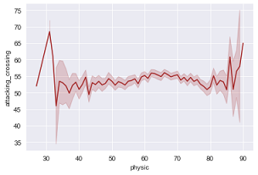

**OBSERVATION:**

* If the physic is less then the attacking crossing is more.
* Otherwise physic range between 35 to 80 the attacking crossing is constant.

**9. IMPACT OF GK DIVING TO GK HANDLING:**

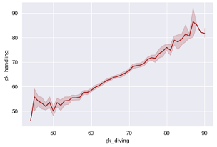

**OBSERVATION:**

* If the gk diving score is increases the gk handling score also increases.

**10. IMPACT OF GK RELEXES TO GK SPPED:**

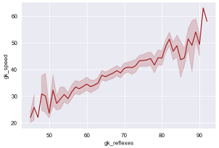

**OBSERVATION:**

* Less gk reflexes then the gk speed also less.
* More gk reflexes then the gk speed also more.

**11. IMPACT OF GK POSITIONING TO GK KICKING:**

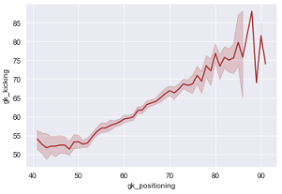

**OBSERVATION:**

* If the gk positioning score is less then the gk kicking score also less.
* If the gk positioning score is increases then the gk kicking score also increases.

**12. IMPACT OF ATTACKING CROSSING TO ATTACKING FINISHING:**

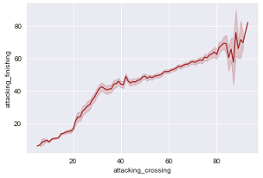

**OBSERVATION:**

* Attacking score between 20 to 40 then attacking finishing score around 40 to 50.
* Either attacking crossing is more then attacking finishing also more

**13. IMPACT OF ATTACKING SHORT PASSING TO ATTACKING VOLLEYS:**

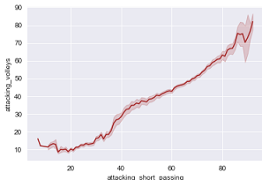

**OBSERVATION:**

* More attacking short passing then the more attacking volleys.
* Less attacking short passing then the less attacking volleys.

**14. IMPACT OF SKILL DRIBBLING TO SKILL BALL CONTROL:**

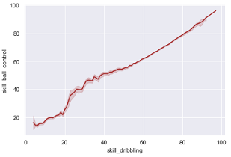

**OBSERVATION:**

* If the dribbling skill is more then ball control skill also more.

**15. RELATION BETWEEN SKILL CURVE AND SKILL FK ACCURACY WITH RESPECT TO PREFERRED FOOT:**

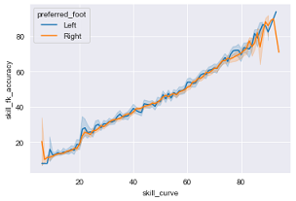

**OBSERVATION:**

* If skill curve is increases then the skill fk accuracy is also increases with both foot.

**16. IMPACT OF SKILL LONG PASSING TO POWER LONG SHOTS:**

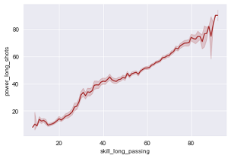

**OBSERVATION:**

* More skills of long passing then the increase of power long shots.

**17. IMPACT OF MOVEMENT SPRINT SPEED TO MOVEMENT REACTION:**

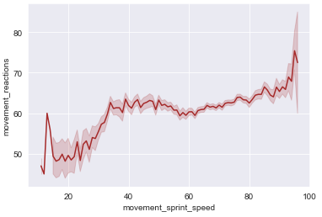

**OBSERVATION:**

* Movement sprint range around 40 to 100 then the movement reaction is constant otherwise fall in both

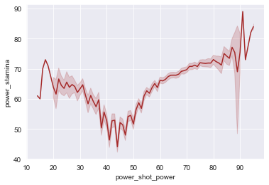**18. IMPACT OF POWER SHOT TO POWER STAMINA:**

**OBSERVATION:**

* If the power shot range around 30 to 60 then the power stamina is decreases
* If the player has more shot power then the stamina is more.

**19. IMPACT OF POWER JUMPING TO POWER STRENGTH:**

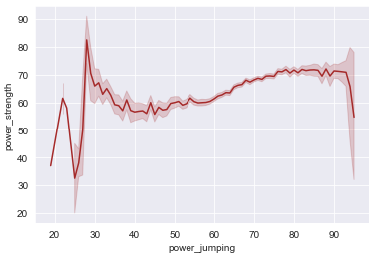

**OBSERVATION:**

* If the power jumping is 30 then the power strength is more and below 30 power jumping less power strength.
* Power jumping above 30 then the power strength is constant

**20. IMPACT TO MENTALITY AGGRESSION TO MENTALITY POSITIONING:**

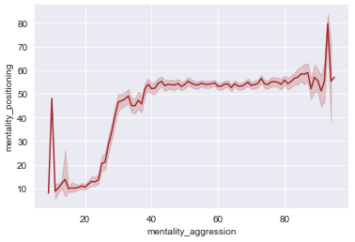

**OBSERVATION:**

* If the mentality aggression around 10 to 30 then the mentality positioning is low
* Below 10 mentality aggression the score of mentality positioning is slightly high. otherwise both metality positioning score is constant.

**21. IMPACT OF MENTALITY PENALTIES TO MENTALITY VISION:**

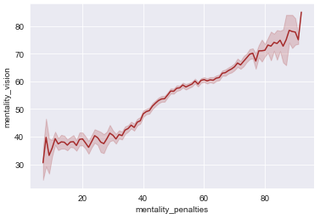

**OBSERVATION:**

* If the penalties is increases then the mentality vision also increases.

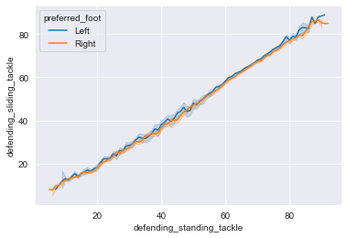**22. RELATION BETWEEN DEFENDING STANDING TACKLE & DEFENDING SLIDING TACKLE WITH RESPECT TO PREFERRED FOOT:**

**OBSERVATION:**

* If defending standing tackle is increases then the defending sliding tackle also increases with both foot

**CATEGORICAL VERIABLE:**

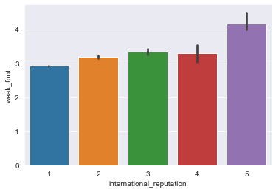**1.IMPACT OF INTERNATIONAL REPUTATION TO WEAK FOOT:**

**OBSERVATION:**

* 5 Intrenational reputation rating of player has more than 4 week foot
* 1 international reputation rating player has less than 3 weak foot
* 2, 3, 4 international reputation player has constant weak foot

**2. IMPACT OF WORK RATE TO SKILL MOVES:**

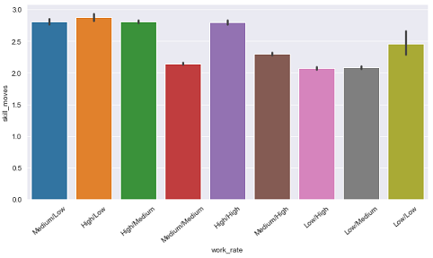

**OBSERVATION:**

* In this plot Cleary seen that 4 types of work rate[medium/low, high/low, high/medium, high/high] has more than 2.5 skill moves
* Other work rate skill moves is less than 2.5

**3. IMPACT OF REAL FACE TO RELEASE CLAUSE EUR:**

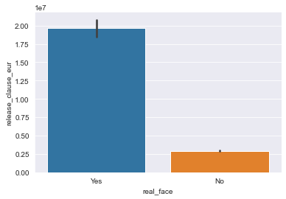

**OBSERVATION:**

* If the player face is real then the release clause is more.
* If the player face is not real then the release clause is less

**4. IMPACT OF PREFERRED FOOT TO PACE:**

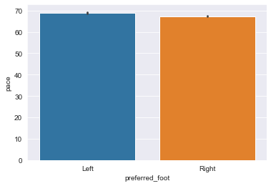

**OBSERVATION:**

* both left and right preferred foot player pace is same.

**5. IMPACT OF TEAM POSITION TO SHOOTING:**

##### 

##### OBSERVATION:

* In this plot we clearly seent that GK team position has no shooting score.
* CF team position has maximum shooting score.

**HERE SOME CONDITION & PLOTTING:**

**1.TOP 10 NATIONALITY PLAYER:**

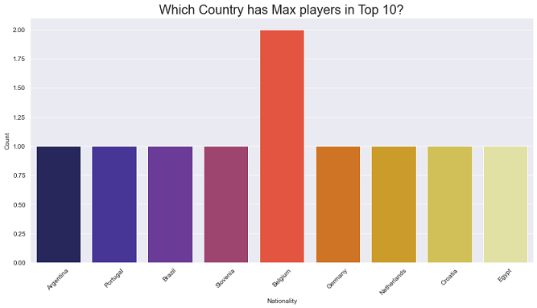

**OBSERVATION**:

* Most of the belgium country player in to 10

**2. TOP 10 CLUB PLAYER:**

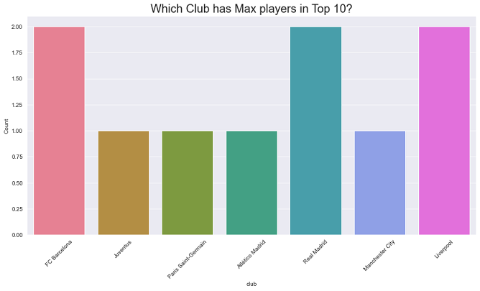

**OBSERVATION:**

* most of the Fc Barcelona. real madrid, and liver pool club player in top 10.

**3. TEAM POSITION IN TOP 10:**

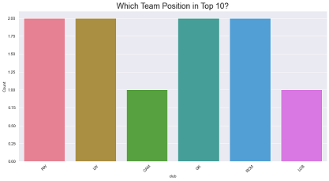

**OBSERVATION:**

* Most of the RW, LW, GK, RCM team position in top 10